Charity no. 1155484

HANDBOOK FOR
school COUNSELLORS

Charity no. 1155484

Room 22, The Trampery
639 High Road
London N17 8AA

Telephone 020 8809 3411

Counselling Manager: counselling@hopeintottenham.com

What this handbook contains

Clinical forms

1. Referral Form 5
Consists of 3 pages: 2 pages of information about the child and a 1-page Strengths and Difficulties Questionnaire intended for use with primary school clients (or a self-report version for secondary school clients, see 3.3 below).

2. Parental Consent Form 8

Evaluation forms

3. Strengths and Difficulties Questionnaires (SDQ) 9

3.1 For parents or teachers of 4-16 year olds 11
3.2 For parents or teachers of 3 and 4 year olds 12
3.3 Self-rated version for 11-17 year olds 13
3.4 Scoring instructions 14
3.5 Interpretation instructions for different versions. 15
3.6 Record sheet for hand-scored questionnaires 16

4. Child Outcome Rating Scales (CORS) 17
To be used by counsellors working in primary schools.

Admin forms

5. Admin checklist 18
All the necessary admin.

6. Monthly stats form 19
Complete monthly in order to be paid.

7. Agreement for further counselling 21
If work continues longer than one term.

8. Closing case summary form 22

9. Termly evaluation form 23
To be filled out by counsellor and school to monitor the project.

Information about the project and your role in the school

10. Terms of Reference 24
Brief overview of the aims and remit of the project.

11. Service Level Agreement 25
Contract between schools and HiT – what you and the school can expect from each other.

12. HiT Schools Counselling team meeting 28
Some information about the monthly team meeting.

Policies

In addition to the general school policies you need to follow, the project has further guidance about the following:

13. Notes 29

14. Child protection 30

15. Referral guidelines 32

Referral Form

Child information
Name: Class:

Date of birth:

Academic achievement: Below Average / Average / Above Average
On the SEN register? YES / NO
On the Child Protection Register? YES / NO
Is the child a looked after child? YES / NO

Family information
Main Carer:

Address:

Telephone numbers:

Siblings in school? Name: Class:
Name: Class:
Name: Class:
Who else lives in the household?

Ethnic origin:

Interpreter needed? What language?

GP name and address:

Other agencies/professionals involved (please tick, and add if necessary)
Educational psychologist |  | Parental outreach team
School nurse |  | Child and Adolescent Mental Health
Occupational therapist |  | Child Development Centre
Social worker |  | Adult Mental Health
Speech and language therapist |  | EWO
Hearing Impairment Advice
Visual Impairment Advice
BIP/BEST

Has the child consented to this referral? YES / NO
Has the parent consented to this referral? YES / NO

Reason for referral

What strategies have already been tried?

Referrer: Date:
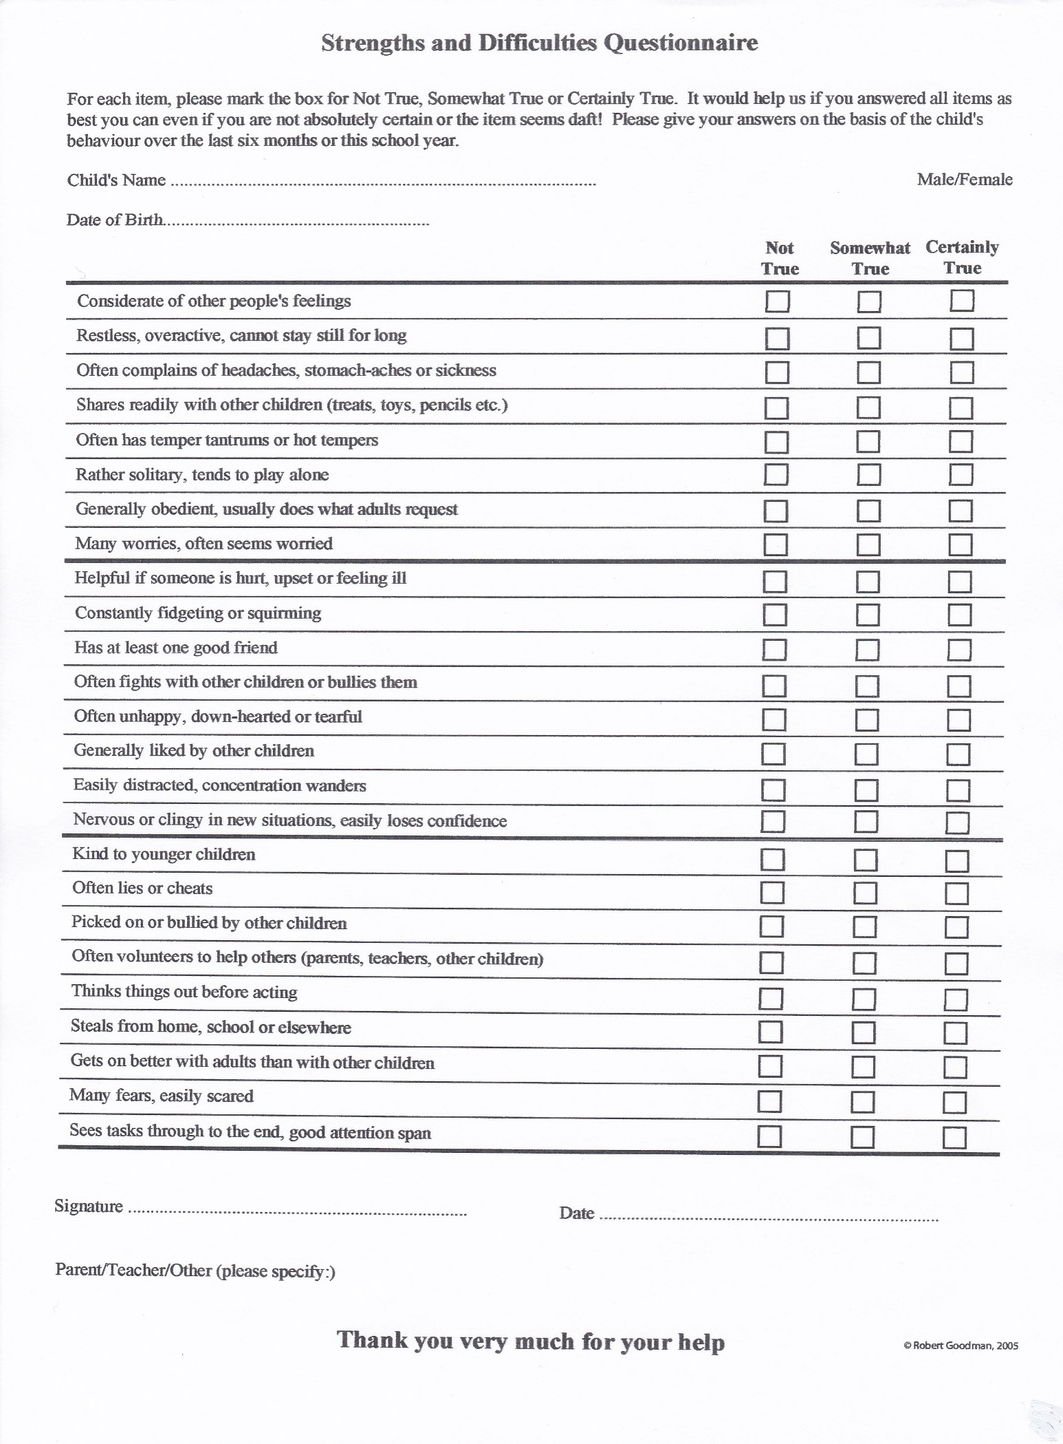

Hope in Tottenham Schools Counselling

PARENTAL CONSENT FORM
Your child is being offered space in a therapeutic play program which aims to help her or his personal, educational and social development. This will provide your child with a safe place to explore their feelings through talk, creative activities and play. Your child may feel happier and more confident and may work better in lessons.
The service is confidential unless your child is at risk for any reason.

If you would like your child to be involved, please complete this form.

I agree to my child taking part in therapeutic play with Hope in Tottenham Schools Counselling Project.

Child’s Name
Name of School
Parent/Carer (please print)
Parent/Carer’s signature
Date

Any comments you wish to make regarding your child’s particular needs:

Hope in Tottenham is GDPR compliant
Strengths and Difficulties Questionnaires

As part of evaluating our work, we use the Strengths and Difficulties Questionnaire (SDQ) before and after each counselling intervention.

The SDQ is a is a brief questionnaire used with 3-17 year olds. It was devised by Robert Goodman as a screening instrument, and is used by many Child and Adolescent Mental Health Services. It doesn’t produce diagnoses, but alerts us to the likelihood of a child having a problem in one of several areas: behaviour (conduct), attention and concentration (hyperactivity), emotional, peer, and prosocial behaviour. The prosocial score refers to desirable behaviour that may balance difficult behaviour and gives some indication of a child’s capacity to think of the needs of others and behave in an appropriate and prosocial way.

The SDQ is administered pre- and post-treatment, in order to assess whether change has occurred.

It exists in several versions. We use a one-sided version with 25 questions in 5 scales:
- emotional symptoms
- behaviour (conduct) problems
- hyperactivity / inattention problems
- peer relationship problems
- prosocial behavior

All items, except for prosocial behaviour, are added together to generate a total difficulties score.

Parents and teachers of 4-16 year olds complete the same 25 items.

There is a slightly modified version for parents or nursery teachers of 3 and 4 year olds.

There is a version available for 11-17 year olds to fill in about themselves.

Scoring cut-off points are calculated so that 80% of children achieve ‘normal’ scores, 10% achieve ‘borderline’ scores, and 10% achieve ‘abnormal’ scores. If a child achieves a borderline or abnormal score on any category in the SDQ, this is a good indicator of significant difficulties.

How we use SDQs

Primary schools:
- The SDQ is filled out by a teacher or someone in the school who knows the child well, as part of the initial referral process. This is the PRE-counselling SDQ and is, in fact, the third page of the referral form.

- After counselling has ended, the child's class teacher or someone in the school who knows the child well completes another SDQ, known as the POST-counselling SDQ.

- It is sometimes helpful for parents to complete questionnaires as well, but this is not required by the project. Because the SDQ has been translated into many different languages, it may be particularly useful if English is not the parents' first language (see www.sdqinfo.org for different language versions.)

Secondary schools:
- The self-report version of the SDQ should be filled out by the client before and after the counselling.

- Where appropriate, a teacher or other staff member, may be asked to fill out SDQs before and after the counselling as well.

Counsellors should not fill out SDQs, but should score them and report the scores to the Counselling Manager using the SDQ Record Sheet.

Please add the following information to the score sheet:
- counsellor intials,
- school,
- whether the questionnaire is pre- or post-counselling,
- any other comments that seem relevant, e.g. if different teachers filled in the pre- and post-questionnaires.
- Use initials rather than full name for each client.

You can score the questionnaires online, but still need to hand in the SDQ record sheet to our manager.

Please make sure that you keep all original questionnaires and score sheets. These are part of the client notes and should be filed in the client's file.

The following questionnaires, scoring instructions and record sheets are appended and can also be found on the website (along with questionnaires in many different languages) at: http://www.sdqinfo.org

1) For parents or teachers of 4-16 year olds
2) For parents or educators of 3-4 year olds
3) For 11-17 year olds to fill out themselves
4) Scoring instructions.
5) Interpretation instructions.
6) Record sheet for hand-scored questionnaires.

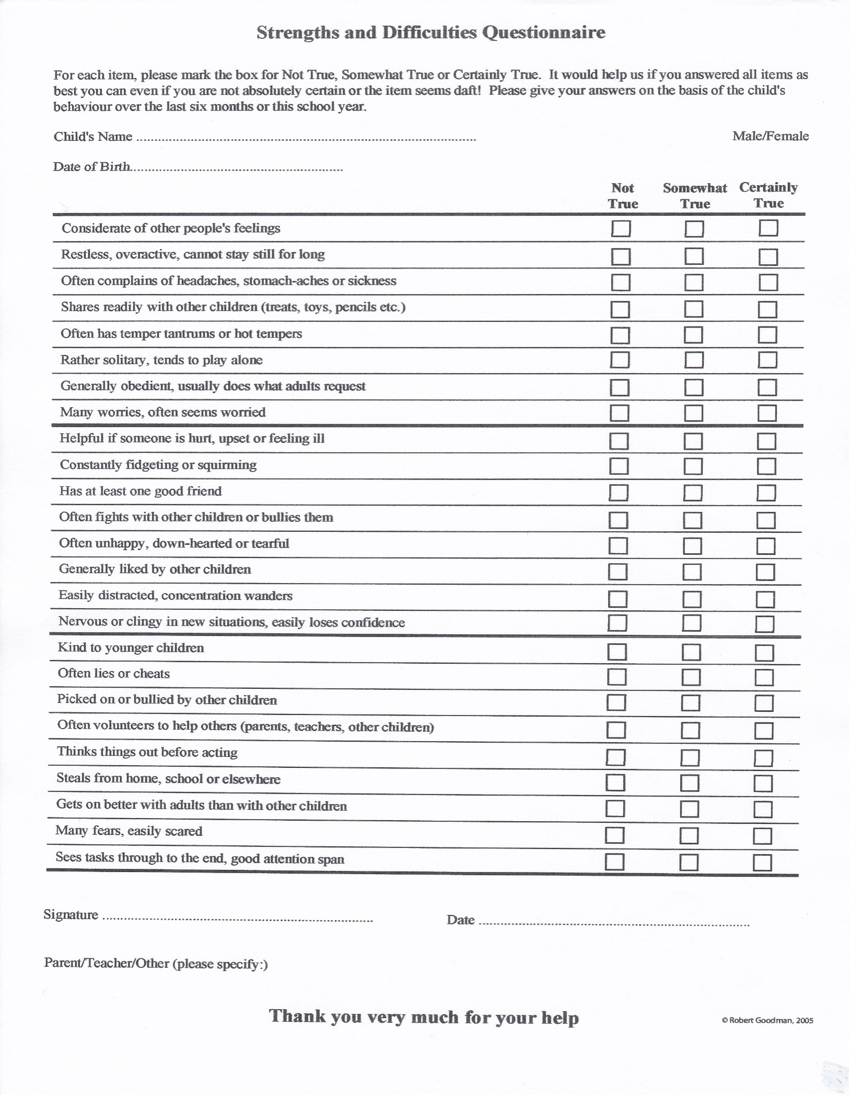
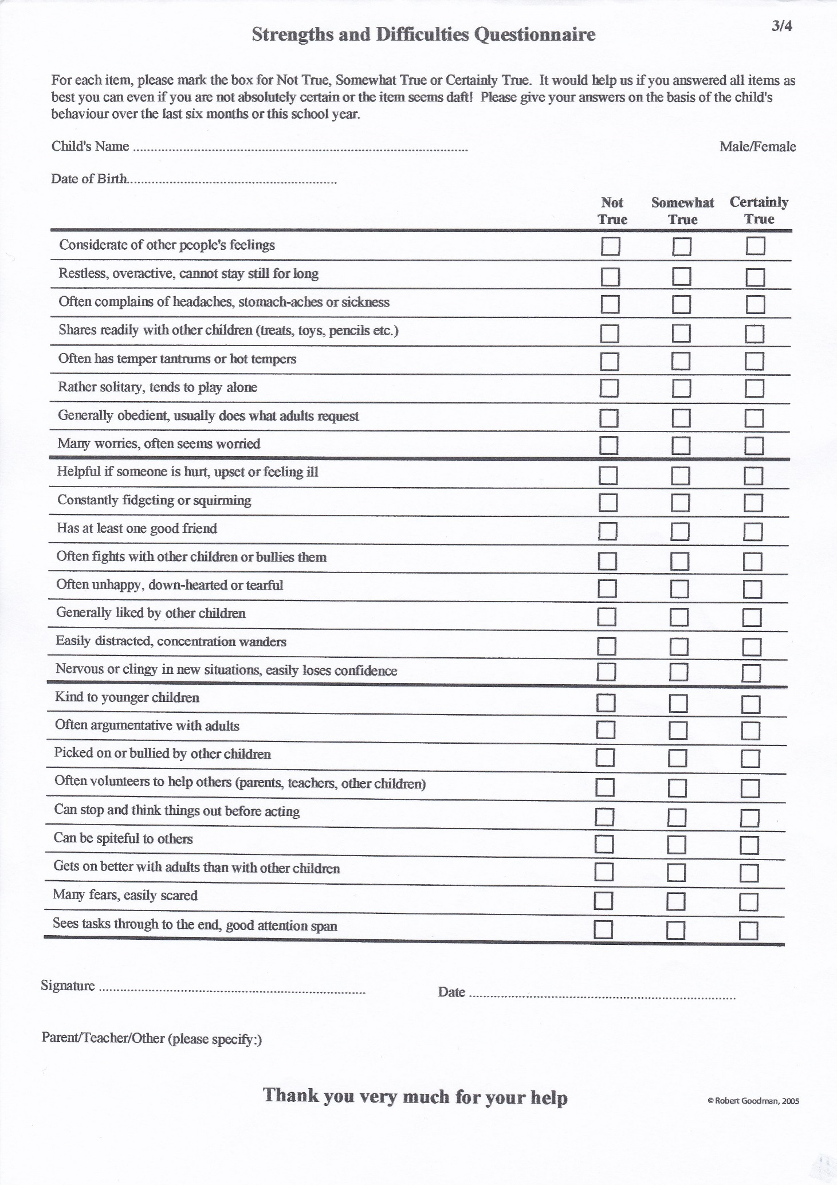
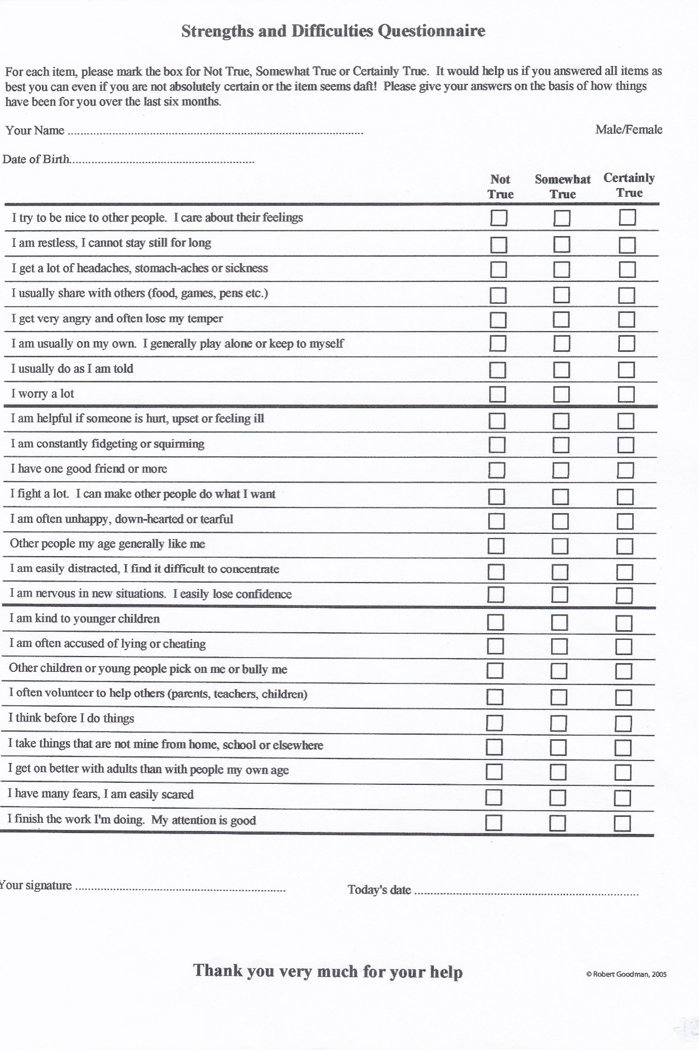
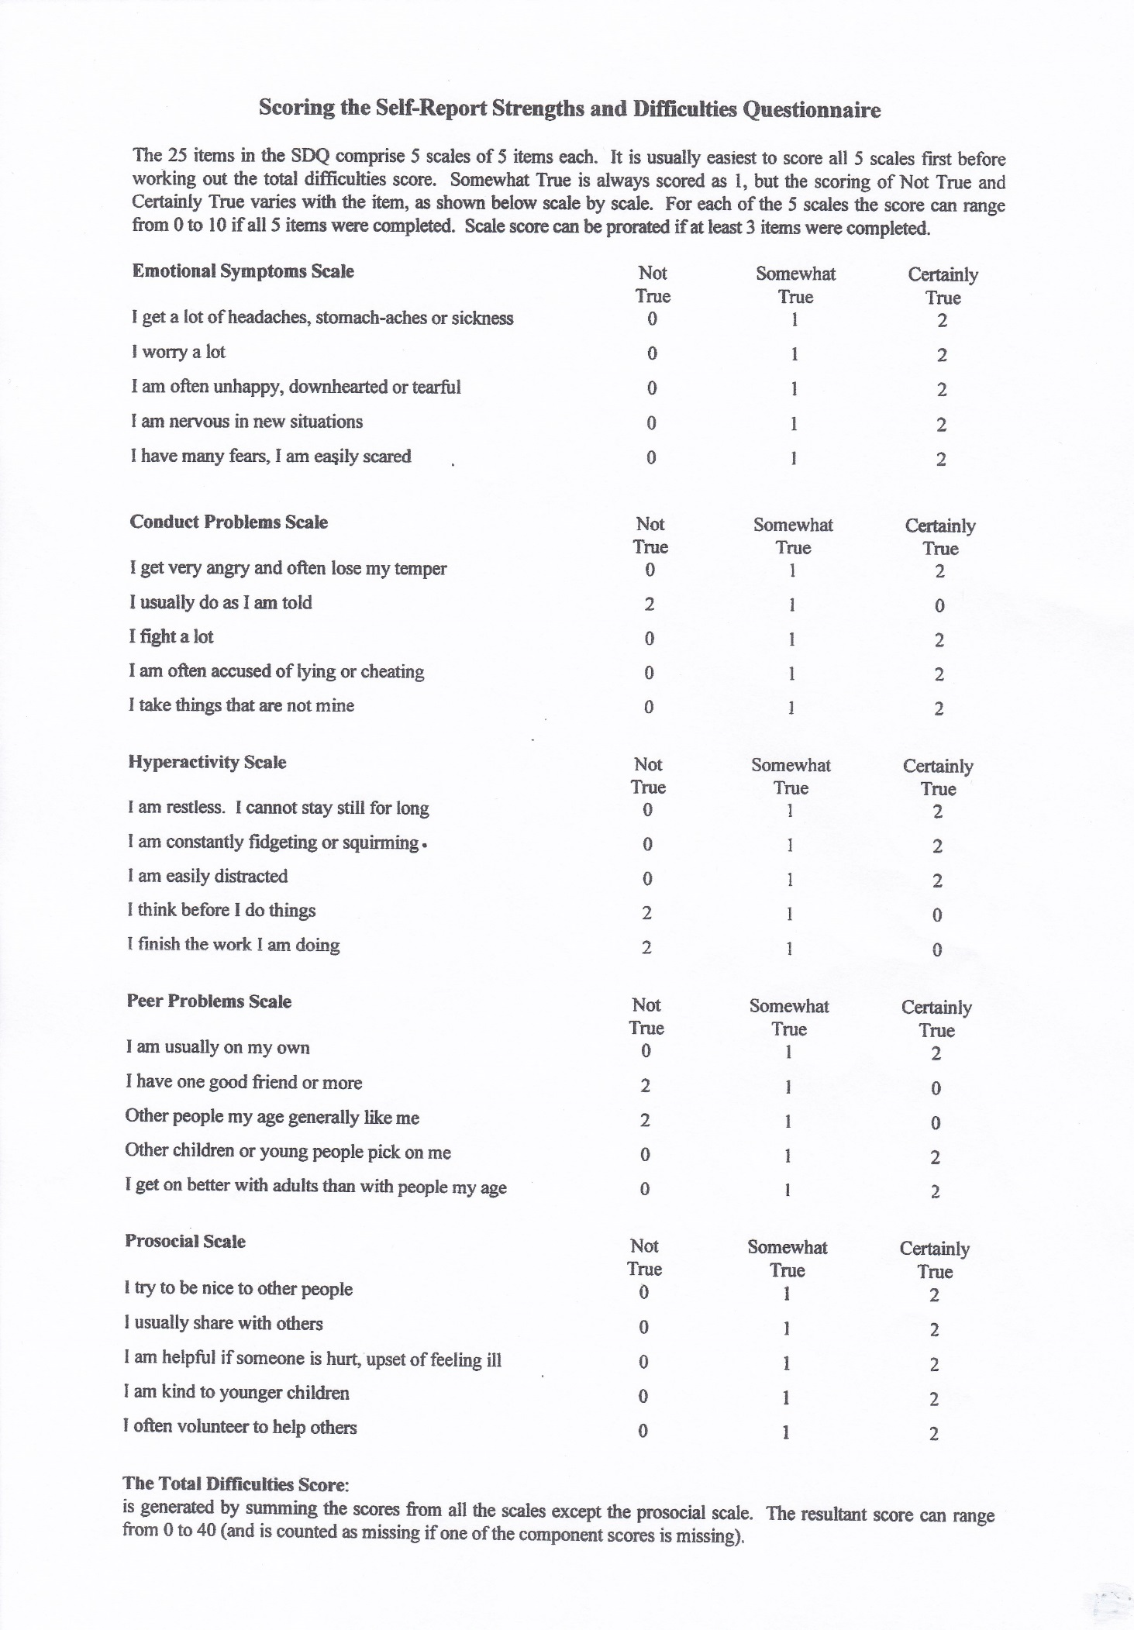
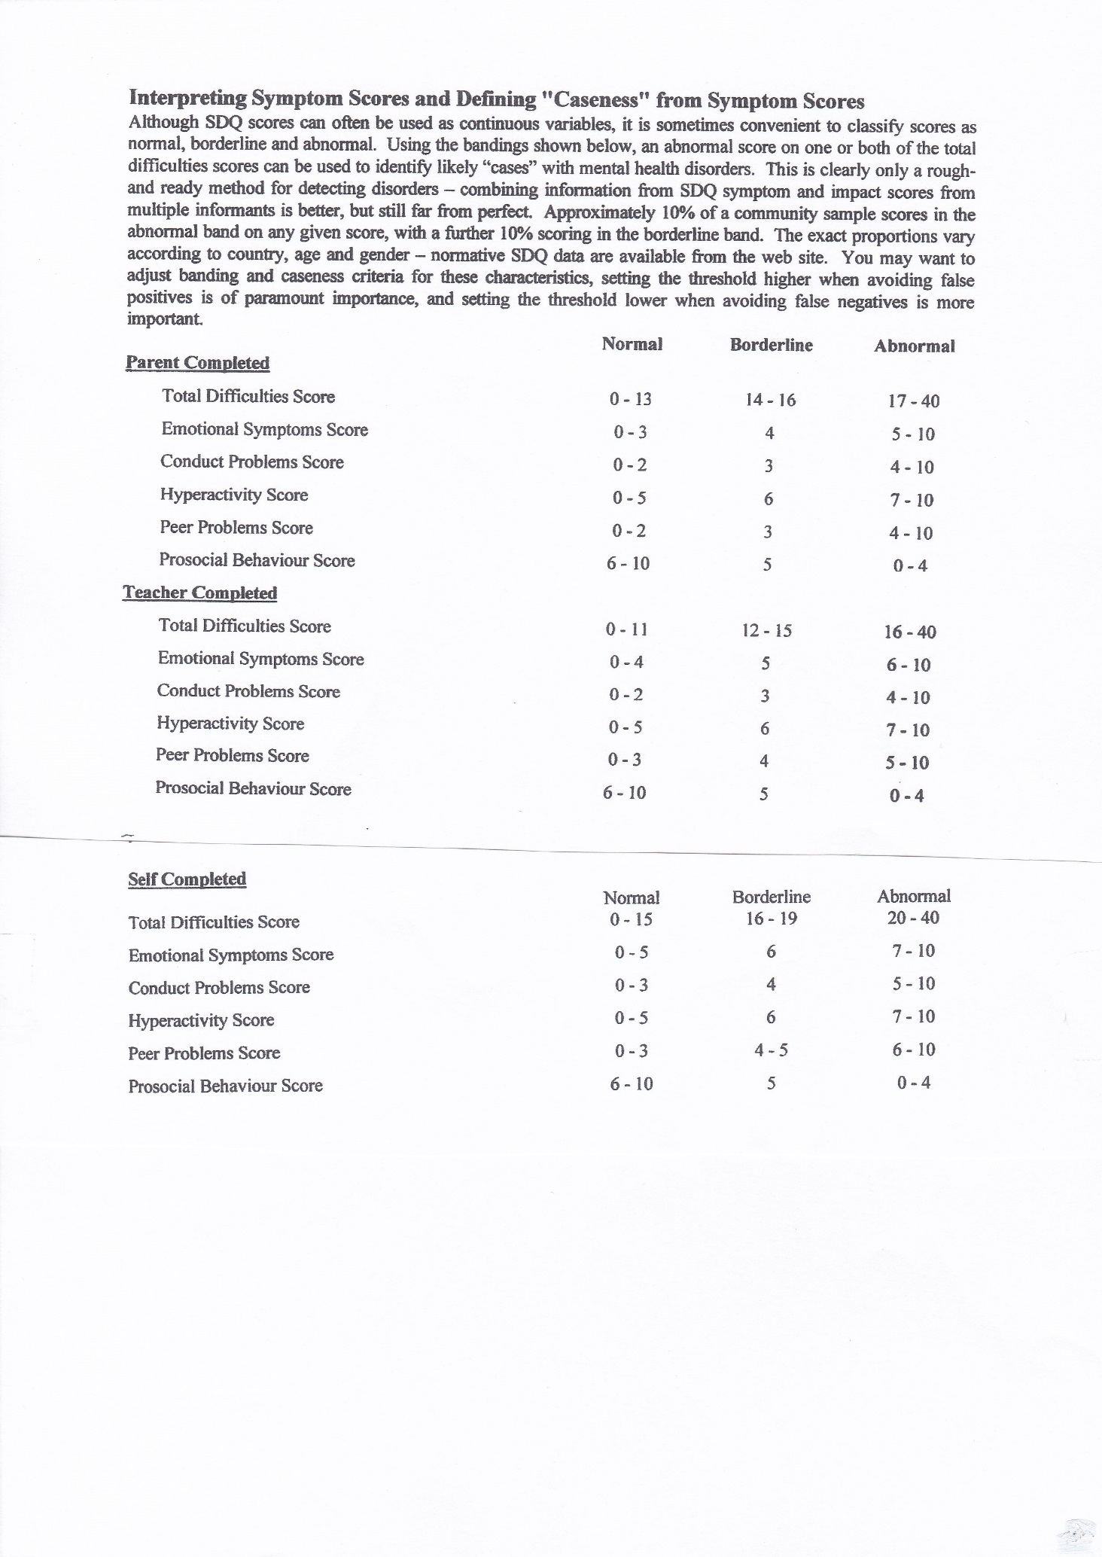
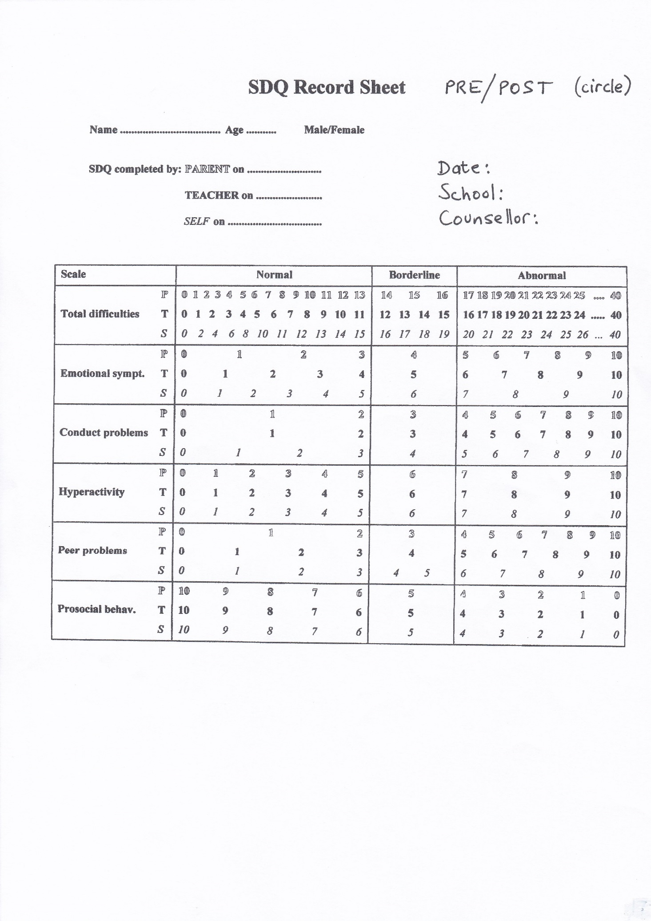

Child Outcome Rating Scale (CORS)
Name ________________________Age (Yrs):____ School: ________________
Sex: M / F_________
PRE or POST counselling? Date: ________________________

How are you doing? How are things going in your life? Please make a mark on the scale to let us know. The closer to the smiley face, the better things are. The closer to the frowny face, things are not so good.

Me
(How am I doing?)

I------------------------------------------------------------------------------------I
Family
(How are things in my family?)

I------------------------------------------------------------------------------------I
School
(How am I doing at school?)

I------------------------------------------------------------------------------------I
Everything
(How is everything going?)

I------------------------------------------------------------------------------------I
_______________________________________

https://www.corc.uk.net/outcome-experience-measures/outcome-rating-scale/

© 2003, Barry L. Duncan, Scott D. Miller, & Jacqueline A. Sparks

Admin Checklist

When starting with each client
Referral form (which includes SDQ): to be filled in by a staff member who knows the child well, before your first session with the child.
Consent form: to be signed by a parent*.
Begin a file for the client (files are available from the counselling manager).
Pre-counselling SDQ: score and complete pre-SDQ record sheet, then send this to the counselling manager.
Stats form: add new client information to your monthly Stats form.
Pre-counselling CORS: complete with the child in your first or second session.
During work with each client
Keep clinical notes of your work.
File all paperwork in the child’s file.
If you, the client, the school and your supervisor agree that work should extend beyond one term, then fill out an Agreement for Further Counselling Form and send it to the counselling manager.
At the end of working with each client
Post-counselling CORS: complete with the child in one of your last sessions.
Post-counselling SDQ: Child's class teacher to complete after termination.*
Score and record post-SDQ on record sheet and send to counselling manager
Write a brief closing summary for the file and give a copy to the school.
Give complete file to counselling manager.
Monthly
Stats form: complete, sign and have it signed by head teacher, then send to counselling manager, so that you can be paid.

*In secondary schools there are some differences:

- Pre- and post-SDQs should be filled in by the young person themselves. If appropriate, pre- and post-SDQs can also be filled in by a school staff member.

- Consent issues: in most cases parental consent is not required, provided the client is able to give informed consent (discuss further with your supervisor as needed).

- CORS forms are not necessary for secondary school clients.

Monthly Stats Form

School: Counsellor: Date:

New client information
Client’s initials
Referral date
Referring agent
Reason for referral
Birth date
Gender
Ethnicity
Language
Postcode
On child protection register?
Child protection concerns?
Known to social services?
Looked after child?
Known disability?

Summary: Number of new clients this month
Total number of clients seen this month
Total number of clients seen this school year
Number of cases closed this month
If onward referral to outside agencies please specify:

Monthly activity

[Please include cancellations (C) and ‘did not arrives’ (DNA) e.g. 3 + 1C would indicate 3 sessions + 1 cancellation]
Client’s initials | Individual/group child sessions | Family sessions | Sessions with parent/s alone | Meetings with professionals
Hours in school:
 | Week 1  Date: | Week 2  Date: | Week 3  Date: | Week 4  Date: | Week 5  Date:
Hours
Cost
Total hours:
Total Cost:

Additional hours:
 | Week 1 | Week 2 | Week 3 | Week 4 | Week 5
Supervision

Team meetings
Training (attended and delivered)
Other
......................
Cost

 |  |  |  | Total hours: Total Cost:

Total hours:

 | Week 1 | Week 2 | Week 3 | Week 4 | Week 5
Total school and additional hours
 |  |  |  | Grand total cost:

Current Rate: £25.36 per hour

Counsellor………………………….....................Headteacher…………………………………….......

Signed ………………………………....................Signed ……………………………………………….

Date: ………………………………........................Date ………………………………………………….
AGREEMENT FOR FURTHER COUNSELLING

(where a client has exceeded one term’s worth of work)

Name

School

Class

Number of weekly sessions already completed

Number of extra sessions now being requested, with any relevant comments/reasons by counsellor

Date extra sessions to commence

Date of next review

Signed and dated

H/T or Sen Co HiT SC Clinical Supervisor HiT SC Manager

(Hope in Tottenham Schools Counselling’s core work is short-term intervention. We are funded and organised for that purpose, but also seek to be flexible where necessary)

CLOSING CASE SUMMARY

Child Information

Child initials | JANUARY |  |  | Case opening date | EMAKEKHHruuuuu
Gender |  |  |  | Case closing date
Age |  |  |  | Number of sessions offered
Date of referral |  |  |  | Number of sessions completed

Reasons for referral:

If the sessions offered were not all completed, please briefly explain why:

Is the child
On the SEN register | Yes ☐ No ☐ Don’t know ☐
On the Child Protection Register | Yes ☐ No ☐ Don’t know ☐
Known to Social Services | Yes ☐ No ☐ Don’t know ☐
A looked-after child | Yes ☐ No ☐ Don’t know ☐

Progress

Pre SDQ score |  |  | If not completed, please explain why:
Post SDQ score

Can you notice any improvement over any of the SDQ categories? Yes ☐ No ☐
If yes, which ones? Please tick:
emotional ☐ conduct ☐ hyperactivity ☐ peer problems ☐ prosocial behaviour ☐

Regardless of the SDQ, have you noticed any improvement? If so, please explain briefly.

Thank you for your help!

Counsellor:_________________ School: _______________________ Date: ___________
HOPE IN TOTTENHAM SCHOOLS COUNSELLING

TERMLY EVALUATION FORM

School:

Counsellor:

Statistical data for whole term:

Total number of clients seen:

Total number of cases opened:

Total number of cases closed:

How has the project progressed in your school this term?

Are there any issues that currently need addressing?

Signed and dated by:

Counsellor:

School contact person:
Hope in Tottenham Schools Counselling
Terms of Reference

- HiT Schools Counselling provides short term counselling for primary and secondary school children and young people whose behaviour or emotional health may be prejudicial to their settled integration in the educational system. ‘Short-term’ is defined as (up to) one full term’s worth of weekly sessions.

- Any extension to a full term’s set of sessions would need to be assessed and then agreed with the project, the counsellor and the school involved before its implementation. The Schools Counselling Project's primary focus is not long-term therapeutic support. This can be provided through appropriate external referral which would be explored as part of the assessment process.

- HiT Schools Counselling also has the flexibility to work with teachers, parents and other groups, including whole classes, although its primary focus will always be individual children’s needs.

- All HiT school counsellors are supervised from within the project in order to ensure similar and consistent working practices and standards across all schools.

- Each school has a nominated contact person (e.g. head teacher or SENCO) with responsibility for liaising with the counsellor and the Project Manager. The contact person gathers referrals and completes referral forms which need to be discussed with the counsellor so as to check the suitability of the referral; keeps the counsellor informed about his/her clients; and maintains contact with the Project Manager if there are concerns about the counselling provision.

- Counselling will be most appropriate for children who are emotionally distressed. These are often children who:

- Are overly quiet, compliant, anxious, withdrawn, worried, sad or angry.

- Have difficulties with friendships and getting on with others, and school interventions haven’t helped.

- Seem persistently distressed or show worrying behaviour change following difficult life events (e.g. death in the family, loss, divorce, separation)

- Counselling may NOT be the most appropriate intervention in the following situations:

- Ongoing, active, unresolved safeguarding issues.
- Looked after children in unstable or short-term placements.
- Ongoing court cases in process.
- Serious mental health concerns (which should be referred to CAMHS).
Hope in Tottenham Schools Counselling
Service Level Agreement

This agreement has been devised to outline the roles of the school, the counsellor and HiT Schools Counselling.

WHAT THE SCHOOL NEEDS TO PROVIDE

Induction of counsellor
The school should inform the counsellor of all relevant protocols appropriate for the appointment (e.g. signing in, identification, a school map with fire exits, relevant school policies etc.).

Provision of a private room
This room should be available for the sole use of the counsellor on the day that s/he is in school, with no need for school staff members to access the room while sessions are in progress. Within the room there should be: -

- Furniture – comfortable chairs (and beanbag or cushions if possible)
- Clock
- Desk/table
- Access to a telephone for confidential calls (or access to a suitable room for same)
- Curtains/blinds/some sort of sound proofing (in order to allow for appropriate privacy).
- Creative materials, toys.

Provision of a lockable space
The school needs to provide a lockable space for the safe - keeping of records and other materials that are confidential.

Referral
The school must appoint a named person – e.g. SENCO, head teacher or learning mentor – to coordinate the referral system and to have an overview of the service.

Possible referrals should be discussed with the counsellor who will assess whether counselling can be of benefit. Some children should more appropriately be referred elsewhere (e.g. Educational Psychology, CAMHS, Social Services, Child Development Centre, etc).

Counselling may not begin before the counsellor has received the completed 3-page referral form (including a Strengths and Difficulties Questionnaire), and the school has obtained parental consent in the case of primary school children. If parental consent is unreasonably withheld this may indicate safeguarding concerns.

At the time of referral, the school should provide a copy of the child’s timetable.

Communication
Schools should provide a tray or pigeon hole for the counsellor e.g. in the school reception office. The counsellor will need the email and telephone numbers of the named contact person and safeguarding officer.

It is essential for schools to set aside time during which the counsellor can discuss individual cases with the named contact person and any other relevant staff member. This should be organised by the named contact person and should take place at least once per half-term and more often if necessary.

Counsellors can offer half hour training annually to all the staff. Time can be allocated for this within a staff meeting or inset day.

Safeguarding
The school counsellor should be informed if there are past or present safeguarding concerns about any child who is referred for counselling. The counsellor will comply with school safeguarding policies and will inform the designated safeguarding lead if any concerns arise during counselling. The school has a responsibility to keep the counsellor informed about how they deal with concerns raised by the counsellor.

WHAT THE SCHOOL CAN EXPECT FROM THE COUNSELLOR

Counsellor availability
The counsellor will be available one day a week.

The counsellor will keep the school and project informed about any absences.

Because of the counsellor’s unique role, s/he will decide on a case by case basis whether it is appropriate to attend other meetings in school related to clients, e.g. IEP review meetings.

Consent
The counsellor must have the child’s consent in order to work with them.

Number of clients and sessions
The counsellor can reasonably be expected to see 4-5 clients per day, with each session lasting 45 -50 minutes. This allows time for cleaning and tidying the room between clients, writing notes and meeting with staff and parents as appropriate.

The number of counselling sessions each client receives will vary. Any proposal for a client to exceed one term of counselling should be agreed in the light of paragraph 2 of the preceding Terms of Reference (see attached).

Confidentiality
The counsellor will maintain confidentiality. In other words s/he may give an opinion about the client and the progress of the work, but will not reveal any details of the counselling sessions, unless there are child protection concerns.

Safeguarding
Counsellors are required to work within local and national safeguarding guidelines. The counsellor will give the school a copy of their DBS certificate.

WHAT THE SCHOOL CAN EXPECT FROM HiT SCHOOLS COUNSELLING

Recruitment and placement
We will recruit a fully qualified and experienced counsellor who will be placed by mutual agreement with the school.

Supervision
We will provide a highly qualified clinical supervisor for the individual counsellor, providing a monthly clinical supervision session to support the work.

Team meetings
We will provide monthly counsellors’ team meetings where your counsellor can discuss relevant clinical and practical matters with their peers.

Reviews
We will arrange termly reviews. While the Schools Counselling Service and the counsellor are new in a school, three-way meetings between all parties will be had. Once established, this review will take the form of the ‘Termly Evaluation form’. This is to be filled in, discussed and signed by the counsellor and the school’s contact person/ head teacher before being forwarded to the HiT Schools Counselling office. We will resume three-way reviews if either the school or the counsellor requests intervention.

Evaluation
We periodically commission evaluation of our services, based in part on data systematically collected by counsellors (Strengths and Difficulties Questionnaires, Child Outcome Rating Scales).

Payment
We will pay the counsellor by BACS at the end of every month. We bill schools termly, in advance. Please pay your termly school’s contribution early to avoid any problems paying your counsellor, as we have very limited cash reserves. If the counsellor is available for work on their scheduled day, but unable to work due to the school being closed or the room or clients being unavailable, we will pay them for that day.

Notice period
Termination of the contract between HiT Schools Counselling and the school requires, for clinical and professional reasons, a minimum of one term’s notice.

Schools Counselling Team Meeting

The team meeting was set up so that counsellors would have a forum to meet and share good practice. The meeting provides a space for counsellors to network and present clinical cases.

The meeting takes place once a month. Each meeting is one and half hours. All counsellors are encouraged to attend, and clinical supervisors occasionally attend. Usually one of the counsellors chairs the meeting and takes notes or delegates this to one of the other counsellors. No clinical details are recorded. These notes are then sent to the counselling manager for circulation to all counsellors and supervisors.

Purpose
- An opportunity for the counsellors to meet each other and network.
- A forum for information sharing e.g. regarding project expansions, funding, recruitment, CPD opportunities etc.
- An opportunity for counsellors to present and discuss their clinical work.
- Identify training gaps and plan CPD where necessary

Policy on Notes and Confidentiality

- Information must be protected and kept confidential.

1.2 Therefore, schools are required to provide counsellors with lockable space for their current notes, according to the service level agreement.

1.3 Notes in current use should not be accessible to a wide range of school staff.

- All notes are the responsibility of Hope in Tottenham. When a case is closed all notes must be filed and returned to Hope in Tottenham, where they will be stored safely.

- Clients are legally entitled to see everything written about them, unless it can be argued that it would be harmful to them. Therefore, notes should be written as if they will be seen by the client or client's family.

- Notes have to be kept indefinitely.

- Handwritten notes should be written in ink, signed and dated.

- Notes for each client must be kept separately from notes for other clients, so that if they are subpoenaed other clients’ confidentiality is not compromised.

- Emails can’t be considered to be entirely secure, so full identifying details should not be included, e.g. use initials instead of names.

Revised 12 October 2018

Cause for Concern about a Child's Safety: What to Do

NB Every counsellor must familiarise themselves with and adhere to the child protection policy of the school they work in.

Cause for concern about a child, that may be a safeguarding issue
⇩
Inform designated Safeguarding Lead at school, face to face, on the same day that the concern arises.

If you have any doubts about this, discuss with your supervisor immediately – but don't delay informing the Safeguarding Lead if your supervisor is not available.
⇩
Write up concern on school's paperwork.
Keep a copy in the child's file (stored in a secure place).
⇩
Inform your supervisor of your concern.

This may be able to wait till your next supervision, but if you're worried discuss with your supervisor as soon as possible.
If information is emailed, alert the supervisor to expect it with a text/voice message. Insecure correspondence should be anonymised (e.g. use initials instead of names in email).
Correspondence to be kept by counsellor in the child's file.

It is the school's responsibility to follow up on safeguarding concerns raised by a counsellor.

The school have a responsibility to inform the counsellor how they have progressed the cause for concern.

These guidelines continue on the next page.
If there are concerns about the school's (lack of) response:

Discuss concerns with designated Safeguarding Lead at school.
⇩
Inform supervisor about concerns. Record discussions in child's file.
⇩
If concerns remain, inform Director of HiT Schools Counselling and record in child's file.
⇩
The director will seek advice from social services directly, and refer to social services if advised to do so. Counsellor will be informed and involved if a referral is made.
⇩
The director of HiT Schools Counselling will inform the school about the referral to social services.

Useful resources

Statutory guidance for schools and colleges on safeguarding children: https://www.gov.uk/government/publications/keeping-children-safe-in-education--2

Haringey Local Safeguarding Children Board
http://www.haringeylscb.org/

Child protection in Haringey
http://www.haringey.gov.uk/index/children-families/childrensocialcare/childprotection.htm

Referral Guidelines

These guidelines are intended to help counsellors select the children most likely to be helped and least likely to be harmed by short-term counselling. Schools have a much briefer version of this in the Terms of Reference. Every situation is unique and needs to be considered carefully – these guidelines can't account for every referral.

The child's needs are our priority, and these are not always the same as the needs of the project, counsellor or school.

Hope in Tottenham counsellors are professionals trained to work one-to-one with children who are emotionally distressed, e.g. children who:
- are overly quiet, shy, compliant, anxious, worried, sad or angry
- have difficulties with friendships where school interventions haven't helped
- seem distressed or show noticeable behaviour change following difficult life events (e.g. death, loss, divorce and separation).

Some of our counsellors have other experience that they bring to their work, e.g. working with groups, parents, families, but this is not the main focus of the project.

The project offers short-term work (a term's worth of weekly sessions, or perhaps a little longer in consultation with the school and clinical supervisor). If this will be too short to help the child then the referral shouldn't be accepted. Opening up painful issues without allowing sufficient time to work with them may be damaging to the child.

e.g. an 8-year old girl removed from her family following severe neglect since birth, and has since had multiple foster family placements, which have broken down for various reasons. Short-term counselling in this situation would feel like another painful rejection for the child.

Counselling may not be suitable in the following situations (although this can be reconsidered if the situation changes):

- children not experiencing any distress internally are less able to make use of counselling;
- ongoing, active, unresolved safeguarding issues;
- looked after children in short-term or unstable placements;
- ongoing court case in process;
- mental health concerns or severe, enduring and complex difficulties (should be referred to CAMHS);
- problems seem to stem from learning difficulties which are not yet being adequately identified and supported;
- undiagnosed and un-assessed mental health, learning or developmental difficulties;
- difficulties exist in the child's environment but the child is managing well e.g. bereaved child is appropriately sad but managing fine;
- parenting problems which are not being addressed (although there is less and less provision for parental support);
- separated parents disputing residence and contact arrangements.

Very occasionally, if the situation is really unclear, counsellors may offer a 3 or 4 session assessment to advise the school on where to refer the child – provided this doesn't raise the child's expectations of being seen for longer.

Some other agencies which should be considered before counselling is agreed:

Child and Adolescent Mental Health Service (CAMHS)
- serious deliberate self-harm and suicidality
- serious depression
- suspected psychosis
- eating disorders
- attachment issues which can't be dealt with in short-term work (e.g. repeated abandonments)
- parent-child relationship difficulties which can't be addressed in individual work with the child and need a systemic intervention.

Child Development Centre (CDC)
- developmental concerns, including e.g. diagnostic assessment of autistic spectrum disorders.

Educational Psychology
- learning difficulties, special educational needs.

Social services
- safeguarding, child protection concerns e.g. domestic violence, parental drug and alcohol misuse, neglect, sexual abuse, physical abuse.

Speech and language therapy

School nursing
- health issues, including bedwetting and incontinence.

Education welfare service
- attendance issues.

